LISTE DES PRIX NOBEL MEMBRES TITULAIRES

DE L’ACADÉMIE EUROPÉENNE DES SCIENCES DES ARTS ET DES LETTRES

DE 1979 À 2004

COMPILATION DES DOCUMENTS ANTE GLIBOTA, SEPTEMBRE 2004
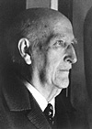
Vicente Aleixandre
The Nobel Prize in
Literature 1977
Spain b. 1898 d. 1984

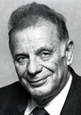
Zhores I. Alferov
The Nobel Prize in Physics 2000
A.F. Ioffe Physico-Technical Institute St. Petersburg, Russia
b. 1930

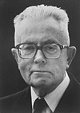
Maurice Allais
The Nobel Prize in Economic Sciences1988
École Nationale Supérieur des Mines de Paris
Paris, France b. 1911

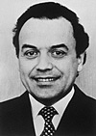
Werner Arber
The Nobel Prize in
Physiology or Medicine 1978
Biozentrum der Universität Basel, Switzerland b. 1929

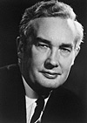
Derek H. R. Barton
The Nobel Prize in Chemistry 1969
Imperial College London, United Kingdom
b. 1918 d. 1998

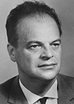
Nicolay Gennadiyevich Basov
The Nobel Prize in Physics1964
P.N. Lebedev Physical Institute
Moscow, USSR ,b. 1922 d. 2001

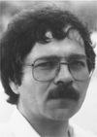
J. Georg Bednorz
The Nobel Prize in Physic1987
IBM Zurich Research Laboratory
Rüschlikon, Switzerland b. 1950

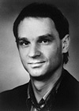
Gerd Binnig
The Nobel Prize in Physics1986
IBM Zurich Research Laboratory
Rüschlikon, Switzerland
b. 1947

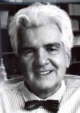
Günter Blobel
The Nobel Prize in Physiology or Medicine 1999
Rockefeller University
New York, NY, USA;
Chevy Chase, MD, USA
b. 1936 in Waltersdorf Germany

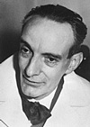
Daniel Bovet
The Nobel Prize in Physiology or Medicine 1957
Istituto Superiore di Sanità
Rome, Italy
b. 1907 d. 1992

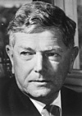
Sir Frank Macfarlane Burnet
The Nobel Prize in Physiologor Medicine 1960
Walter and Eliza Hall Institute for Medical Research Melbourne,
b. 1899 d. 1985

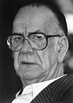
Camilo José Cela
The Nobel Prize in Literature 1989
Spain
b. 1916 d. 2002
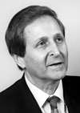
Claude Cohen-Tannoudji
The Nobel Prize in Physics 1997
Collège de France; École Normale Supérieure
Paris, France b. 1933

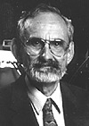
Robert F. Curl Jr
The Nobel Prize in Chemistry 1996
Rice University Houston,
TX, USA b. 1933

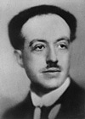
Prince Louis-Victor Pierre Raymond de Broglie
The Nobel Prize in Physics 1929
Sorbonne University, Institut Henri Poincaré Paris, France
b. 1892 d. 1987
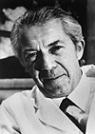
Christian de Duve
The Nobel Prize in Physiology or Medicine 1974
Rockefeller University
New York, NY, USA
b. 1917 Belgium

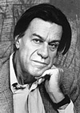
Pierre-Gilles de Gennes
The Nobel Prize in Physics 1991
Collège de France Paris, France
b. 1932

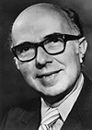
Renato Dulbecco
The Nobel Prize in Physiology or Medicine 1975
Imperial Cancer Research Fund Laboratory London, United Kingdom
b. 1914 in Catanzaro Italy
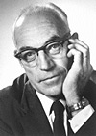
Sir John Carew Eccles
The Nobel Prize in Physiology or Medicine 1963
Australian National University
Canberra, b. 1903 d. 1997

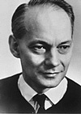
Manfred Eigen
The Nobel Prize in Chemistry 1967
Max-Planck-Institut für Physikalische Chemie
Goettingen, Germany
b. 1927

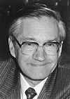
Richard R. Ernst
The Nobel Prize in Chemistry 1991
Eidgenössische Technische Hochschule Zurich, Switzerland
b. 1933
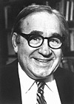
Robert W. Fogel
The Nobel Prize in Economic Sciences 1993
University of Chicago
Chicago, IL, USA b. 1926

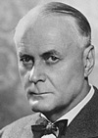
Ragnar Granit
The Nobel Prize in Physiology or Medicine 1967
Karolinska Institutet
Stockholm, Sweden
b. 1900(in Helsinki, Finland)
d. 1991

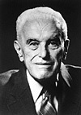
John C. Harsanyi
The Nobel Prize in Economic Sciences 1994
University of California Berkeley, CA, USAb. 1920(in Budapest, Hungary) d. 2000
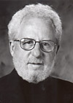
Alan J. Heeger
The Nobel Prize in Chemistry 2000
University of California
Santa Barbara, CA, USA b. 1936

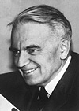
Gerhard Herzberg
The Nobel Prize in Chemistry 1971
National Research Council of Canada Ottawa, b. 1904
(in Hamburg, Germany)
d. 1999

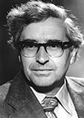
Antony Hewish
The Nobel Prize in Physics 1974
University of Cambridge
Cambridge, United Kingdom
b. 1924
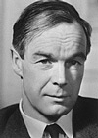
Alan Lloyd Hodgkin
The Nobel Prize in Physiology or Medicine 1963
University of Cambridge
Cambridge, United Kingdom
b. 1914 d. 1998

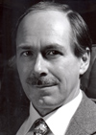
Gerardus 't Hooft
The Nobel Prize in Physics 1999
Utrecht University Netherlands
b. 1946

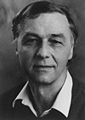
Robert Huber
The Nobel Prize in Chemistry 1988
Max-Planck-Institut für Biochemie
Martinsried, Germany b. 1937

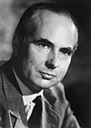
Andrew Fielding Huxley
The Nobel Prize in Physiology or Medicine 1963
London University
United Kingdom b. 1917

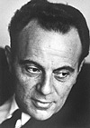
François Jacob
The Nobel Prize in Physiology or Medicine 1965
Institut Pasteur
Paris, France b. 1920

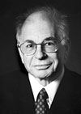
Daniel Kahneman
The Nobel Prize in Economic Sciences 2002
Princeton University
Princeton, NJ, USA
b. 1934

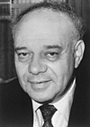
Jerome Karle
The Nobel Prize in Chemistry 1985
US Naval Research Laboratory
Washington, DC, USA b. 1918

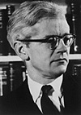
John Cowdery Kendrew
The Nobel Prize in Chemistry 1962
MRC Laboratory of Molecular Biology Cambridge, United Kingdomb. 1917 d. 1997

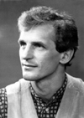
Wolfgang Ketterle
The Nobel Prize in Physics 2001
Massachusetts Institute of Technology (MIT) Cambridge,USA
b. 1957 in Germany
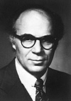
Lawrence R. Klein
The Nobel Prize in Economic Sciences 1980
University of Pennsylvania
Philadelphia, PA, USA b. 1920

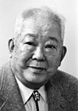
Masatoshi Koshiba
The Nobel Prize in Physics 2002
University of Tokyo
Tokyo, Japan b. 1926

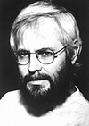

Georges J.F. Köhler
The Nobel Prize in Physiology or Medicine 1984
Basel Institute for Immunology
Basel, Switzerland b. 1946 d. 1995
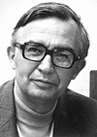
Jean-Marie Lehn
The Nobel Prize in Chemistry 1987
Université Louis Pasteur
Strasbourg, France; Collège de France Paris b. 1939

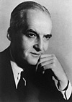
Luis F. Leloir
The Nobel Prize in Chemistry 1970
Institute for Biochemical Research
Buenos Aires, Argentina
b. 1906 d. 1987

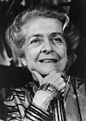
Rita Levi-Montalcin
The Nobel Prize in Physiology or Medicine 1986
Institute of Cell Biology of the C.N.R Rome, Italy b. 1909
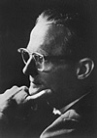
William N. Lipscomb
The Nobel Prize in Chemistry 1976
Harvard University
Cambridge, MA, USA b. 1919

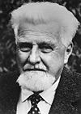
Konrad Lorenz
The Nobel Prize in Physiology or Medicine 1973
Österreichische Akademie der Wissenschaften, Institut für vergleichendeVerhaltensforschung
Altenberg, Austriab. 1903d. 1989

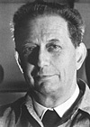
André Lwoff

The Nobel Prize in Physiology or Medicine 1965
Institut Pasteur ,Paris, France
1902 - 1994

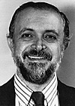
Mario J. Molina
The Nobel Prize in Chemistry 1995
Massachusetts Institute of Technology (MIT) Cambridge, USA b. 1943 in Mexico City

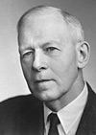

Robert S. Mulliken
The Nobel Prize in Chemistry 1966
University of Chicago
Chicago, IL, USA
b. 1896d. 1986

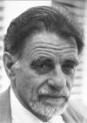
K. Alexander Müller
The Nobel Prize in Physics 1987
IBM Zurich Research Laboratory Rüschlikon, Switzerland b. 1927

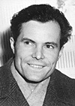
Rudolf Ludwig Mössbaue
The Nobel Prize in Physics 1961
Technical University Munich, Germany; California Institute of Technology Pasadena,USA
b. 1929 in Germany

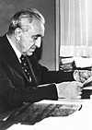
Louis Eugène Félix Néel
The Nobel Prize in Physics 1970
University of Grenoble
Grenoble, France b. 1904 d. 2000

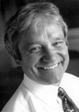
Sir Paul M. Nurse
The Nobel Prize in Physiology or Medicine 2001
Imperial Cancer Research Fund
London, United Kingdom
b. 1949
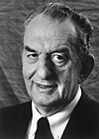
George A. Olah
The Nobel Prize in Chemistry 1994
University of Southern California
Los Angeles, CA, USA
b. 1927 (in Budapest, Hungary)

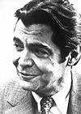
George E. Palade
The Nobel Prize in Physiology or Medicine 1974
Yale University, School of Medicine New Haven, CT, USA
b. 1912(in Iasi, Romania)

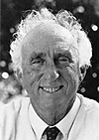
Martin L. Perl
The Nobel Prize in Physics 1995
Stanford University
Stanford, CA, USA
b. 1927
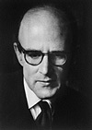
Max Ferdinand Perutz
The Nobel Prize in Chemistry 1962
MRC Laboratory of Molecular Biology Cambridge, United Kingdomb. 1914(in Vienna, Austria)d. 2002

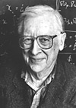
John A. Pople
The Nobel Prize in Chemistry 1998
Northwestern University
Evanston, IL, USA b.1925 d. 2004

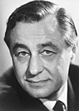
George Porter
The Nobel Prize in Chemistry 1967
Royal Institution of Great Britain
London, United Kingdom
b. 1920 d. 2002
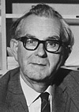
Rodney R. Porter
The Nobel Prize in Physiology or Medicine 1972
University of Oxford
Oxford, United Kingdom
b. 1917 d. 1985

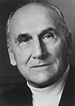
Vladimir Prelog
The Nobel Prize in Chemistry 1975
Swiss Federal Institute of Technology, Zurich,
b. 1906 in Sarajevo, d. 1998

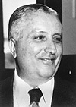
Ilya Prigogine
The Nobel Prize in Chemistry 1977
Université Libre de Bruxelles
Brussels, Belgium b. 1917
(in Moscow, Russia)d. 2003
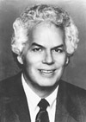
Stanley B. Prusiner
The Nobel Prize in Physiology or Medicine 1997
University of California School of Medicine San Francisco, CA, USA
b. 1942

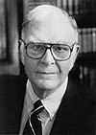
F. Sherwood Rowland
The Nobel Prize in Chemistry 1995
University of California
Irvine, CA, USA b. 1927

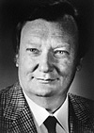
Carlo Rubbia
The Nobel Prize in Physics 1984
CERN Geneva, Switzerland
b. 1934

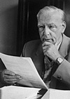
Ernst Ruska
The Nobel Prize in Physics 1986
Fritz-Haber-Institut der Max-Planck-Gesellschaft Berlin, Germany b. 1906 d. 1988

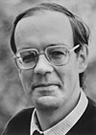
Bert Sakmann
The Nobel Prize in Physiology or Medicine 1991
Max-Planck-Institut für medizinische Forschung
Heidelberg, Germany b. 1942

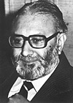
Abdus Salam
The Nobel Prize in Physics 1979
International Centre for Theoretical Physics Trieste,Italy
b. 1926 Pakistan d. 1996
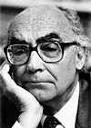
José Saramago
The Nobel Prize in Literature 1998
Portugal b. 1922

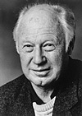
Michael Smith
The Nobel Prize in Chemistry 1993
University of British Columbia Vancouver, Canada b. 1932
(in Blackpool, United Kingdom)
d. 2000

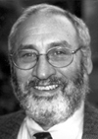
Joseph E. Stiglitz
The Nobel Prize in Economic Sciences 2001
Columbia University
New York, NY, USA
b. 1943
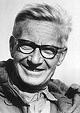
Nikolaas Tinbergen
The Nobel Prize in Physiology or Medicine 1973
University of Oxford
,United Kingdomb. 1907(in the Hague, the Netherlands)d. 1988

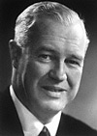
Lord (Alexander R.) Todd
The Nobel Prize in Chemistry 1957
University of Cambridge , United Kingdom b. 1907 d. 1997

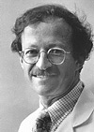
Harold E. Varmus
The Nobel Prize in Physiology or Medicine 1989
University of California School of Medicine San Francisco,USA
b. 1939
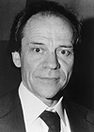
Torsten N. Wiesel
The Nobel Prize in Physiology or Medicine 1981
Harvard Medical School Boston, MA, USA b. 1924 in Sweden

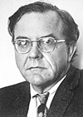
Geoffrey Wilkinson
The Nobel Prize in Chemistry 1973
Imperial College London, United Kingdom b. 1921 d. 1996

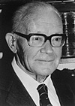
Georg Wittig
The Nobel Prize in Chemistry 1979
University of Heidelberg
Heidelberg, Germany
b. 1897 d. 1987
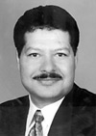
Ahmed H. Zewail
The Nobel Prize in Chemistry 1999
Egypt and USA California Institute of Technology Pasadena, USA
b. 1946

